**QlikView Project Model and visualization:**

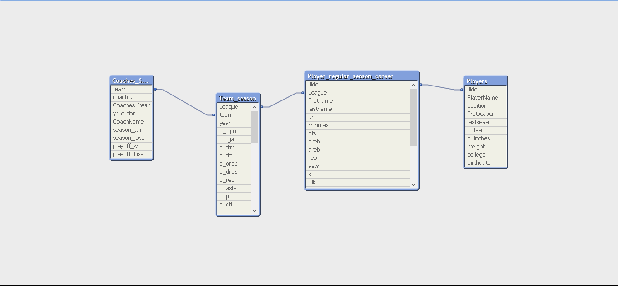

**Intro:**

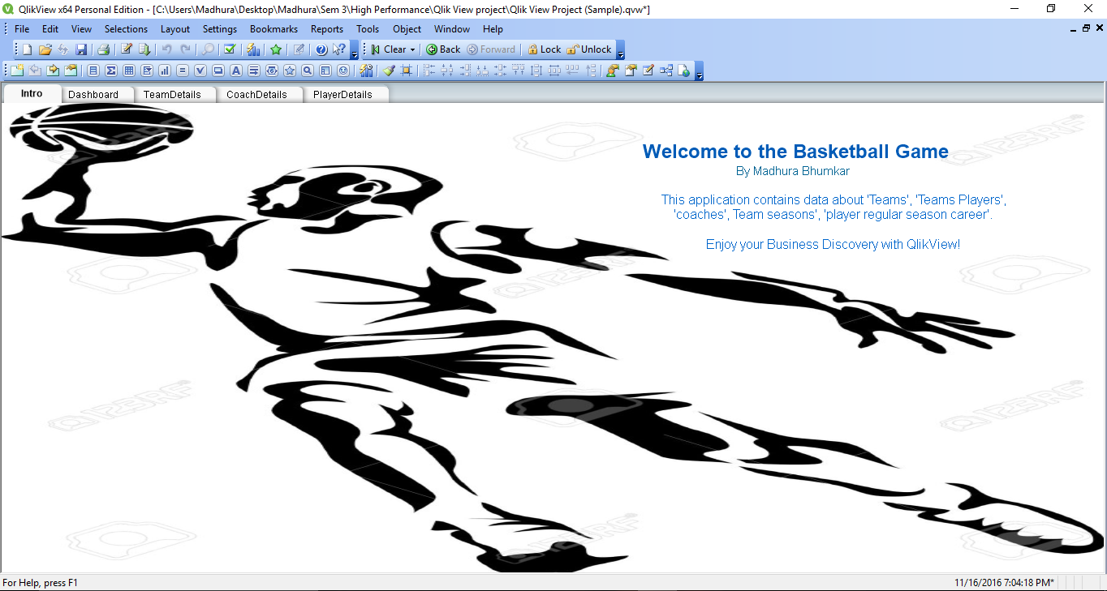

**Dashboard:**

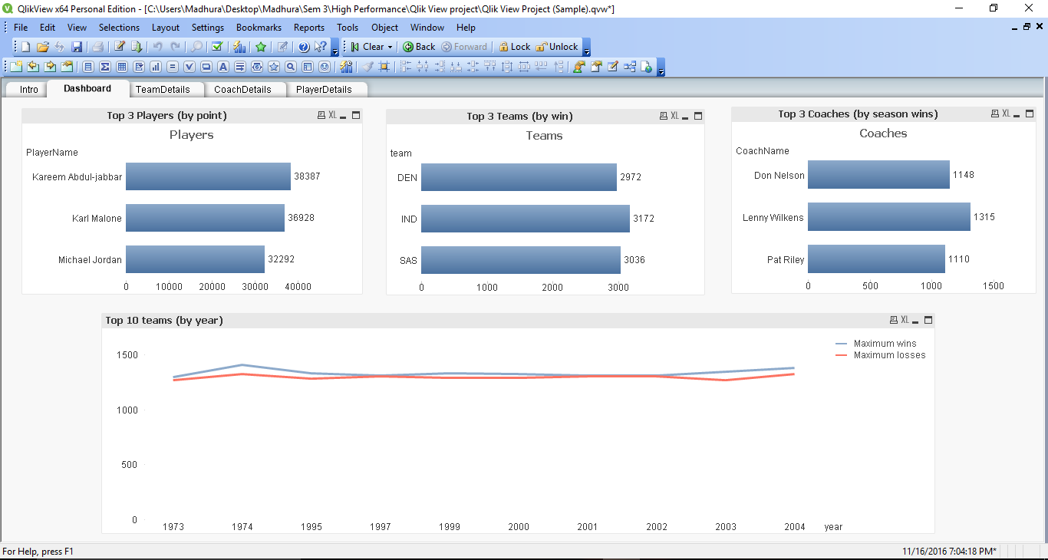

**Team Details:**

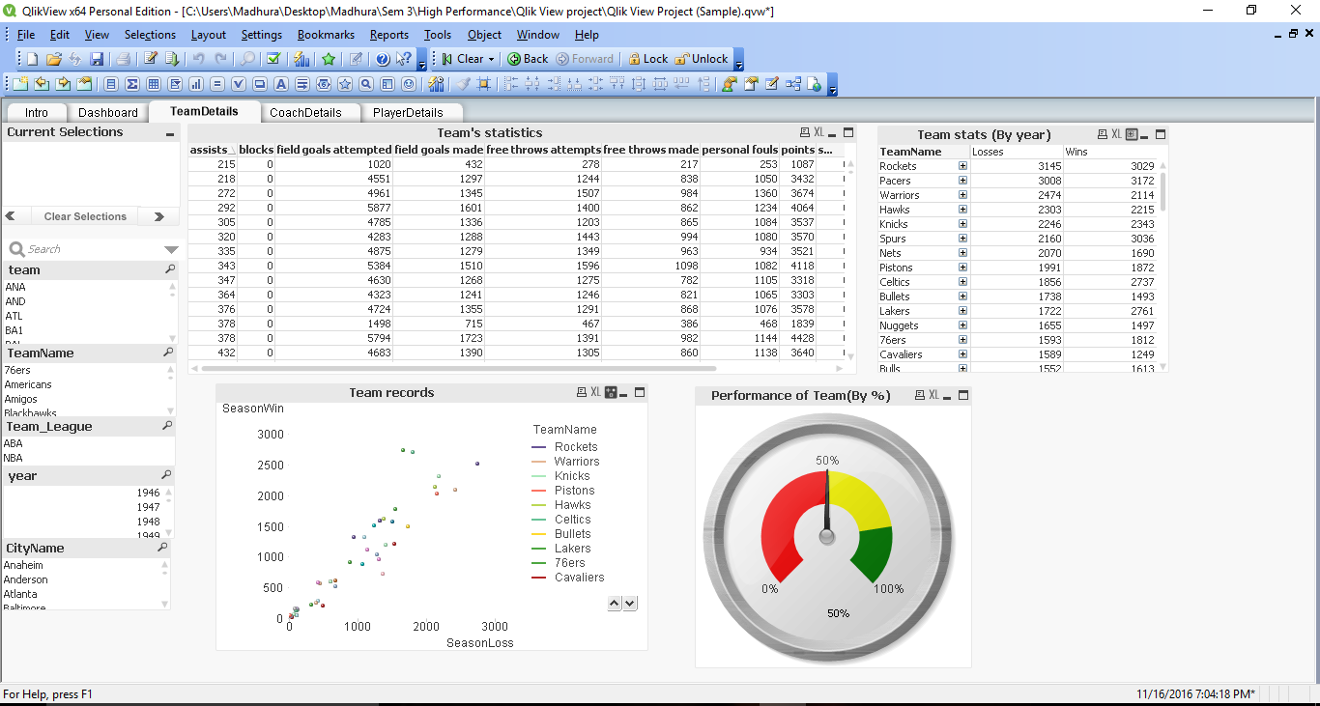

**Coach Details:**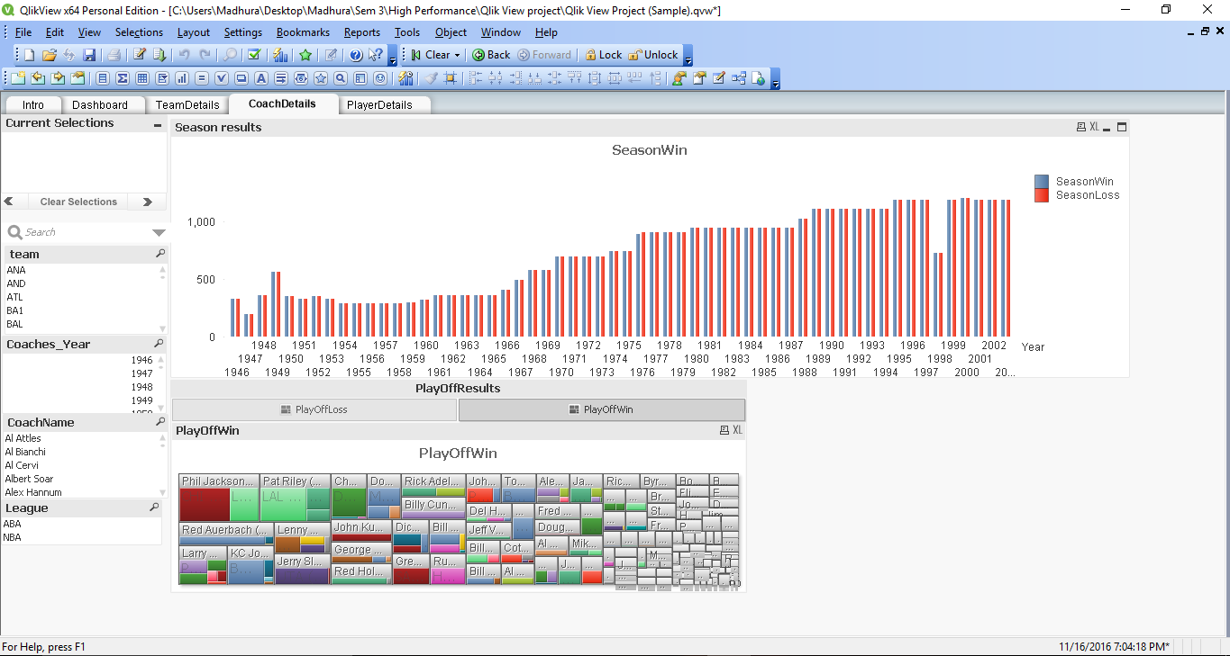

**Player Details:**

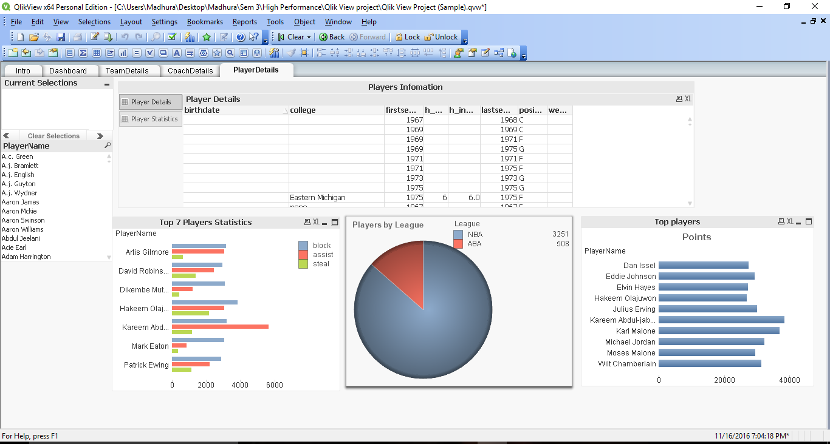

**After selecting year 1947 in Team Details:**

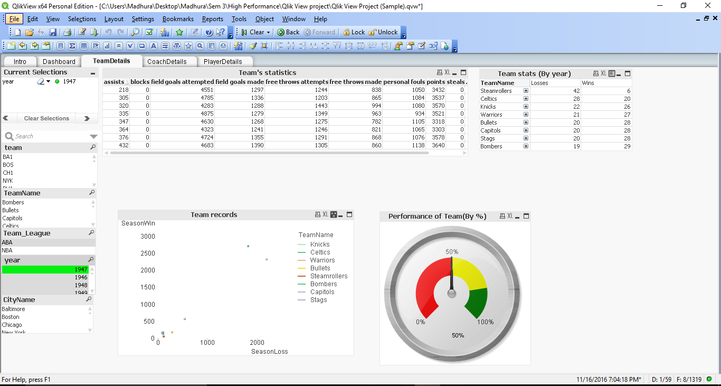

**After selecting Team: ATL & Coach Name: BOB Weiss in Coach Details**

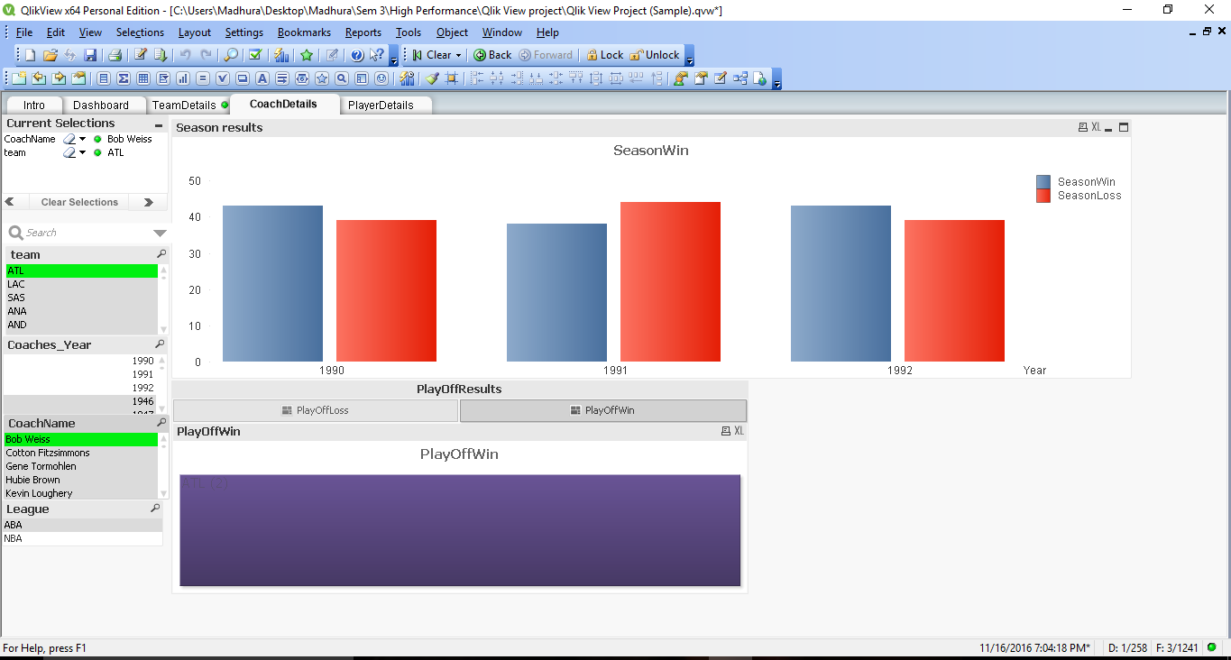

**After selecting Team: 76ers and Player Name: A. J. Guyton in Players Details:**

